**Practical No. 4**

**Operator overloading**

**Program 4(a):**

Overload the operator unary (-) for demonstrating operator overloading.

Example:

Write a program to negate the values of two variables contained in an object by overloading the operator unary negate i.e. ‘-’.

**Coding:**

#include<iostream.h>

#include<conio.h>

class negate

{

int x,y;

public:

void read()

{

cout<<"Enter two numbers:";

cin>>x>>y;

}

void operator-()

{

x=-x;

y=-y;

}

void display()

{

cout<<"x="<<x<<endl<<"y="<<y;

}

};

void main()

{

clrscr();

negate n;

n.read();

-n;

n.display();

getch();

}

**Output:**

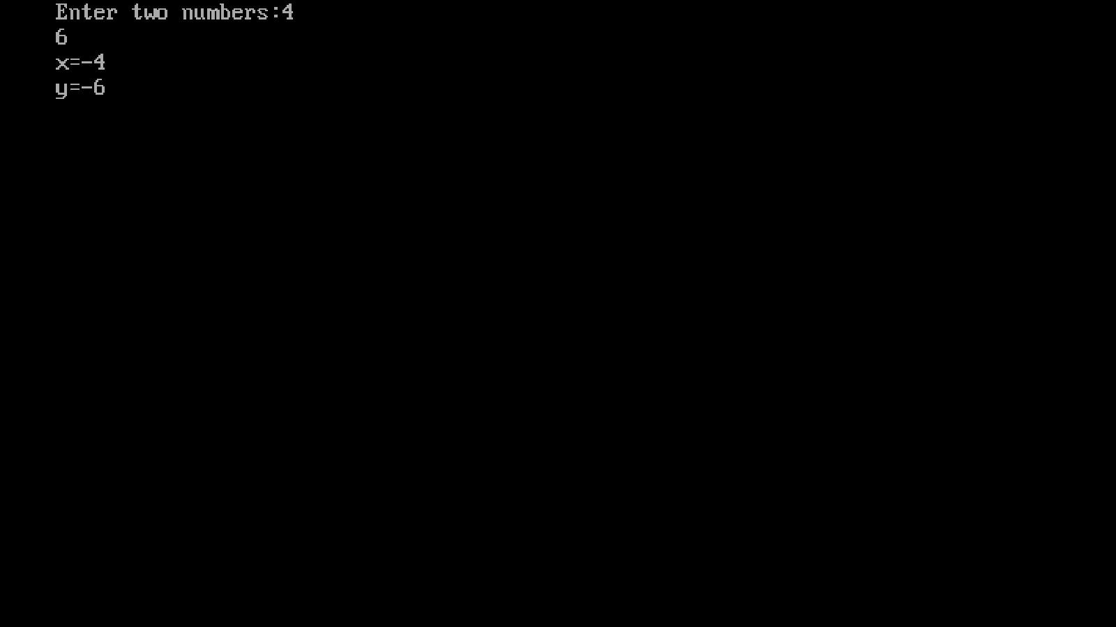

**Program 4(b):**

Overload the operator + for adding the timings of two clocks and also pass objects as an arguments.

**Example:**

Write a program to add two time entered by the users in hours and minutes using overload binary operator ”+”.

Coding:

#include<iostream.h>

#include<conio.h>

class negate

{

int x,y;

public:

void read()

{

cout<<"Enter two numbers:";

cin>>x>>y;

}

void operator-()

{

x=-x;

y=-y;

}

void display()

{

cout<<"x="<<x<<endl<<"y="<<y;

}

};

void main()

{

clrscr();

negate n;

n.read();

-n;

n.display();

getch();

}

**Output:**

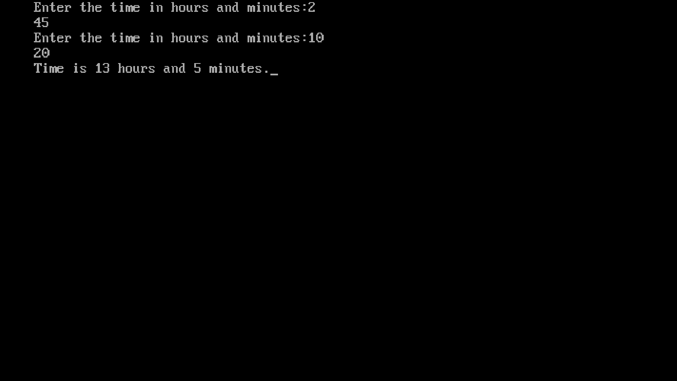

**Program:**

Overload the + for concatenating the two strings.

For e.g. “Py” + “thon”=Python

**Coding:**

#include<iostream.h>

#include<conio.h>

class string

{

char a[20];

public:

void read()

{

cout<<"Enter a string:";

cin>>a;

}

void operator + (string d)

{

string dr;

int i=0,j=0;

while(a[i]!='\0')i++;

do

{

a[i]=d.a[j];

j++;

i++;

}while(d.a[j]!='\0');

a[i]=d.a[j];

}

void display()

{

cout<<"String is:"<<a;

}

};

void main()

{

clrscr();

string d1;

string d2;

d1.read();

d2.read();

d1+d2;

d1.display();

getch();

}

**Output:**

